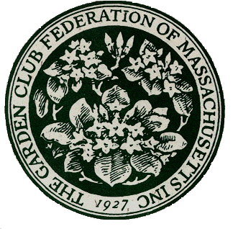**The Garden Club Federation of Massachusetts**

**400 Fifth Ave., Suite 110, Waltham, MA 02451**

**781-237-0336**

**GCFMStateAwards@gmail.com**

**APPLICATION FOR STATE AWARD for Calendar year 2023 Submissions due December 1, 2023**

**Exceptions: Not for Flower Show achievement awards, Special Awards, and Civic Development and Historic Preservation Grants**

The application consists of 5 pages:

Page 1 – cover sheet

Page 2 – submitter and club information

Pages 3, 4, 5 – narrative responses to topics 1 – 6

**PAGE 1 - COVER SHEET**

* Please review these instructions before submitting your application.
* If you have questions or need assistance, please email the Awards Chair at [**GCFMStateAwards@gmail.com**](mailto:GCFMStateAwards@gmail.com)
* This is the cover sheet. The application follows.
* Refer to the [GCFM webpage](https://www.gcfm.org/) Awards tab for the Rules for State Awards

document for descriptions and additional information.

* Application narrative is limited to three pages – front of pages only.
* Application and supporting material will not be returned.
* Awards year is January 1 – December 31.
* Do not submit an exact duplicate application for more than one award.
* Copy your entry for your files.
* All entries should be sent electronically as a PDF or Word document.
* **Email completed application to** [**GCFMStateAwards@gmail.com**](mailto:GCFMStateAwards@gmail.com)

to arrive by 11:59 PM on December 1.

**PAGE 2 - SUBMITTER AND CLUB INFORMATION SHEET**

**For all applications:**

Name of State Garden Club: Garden Club Federation of Massachusetts

Number in State Garden Club: 10,436 members 168 Clubs

State Awards Chair: Lisa Murray

Phone: 978-302-1063

Email: gcfmstateawards@gmail.com

**For your submission, complete the following items:**

Award #:

Award Name:

Today’s Date:

Your Name :

Phone:

E-mail:

Club name:

[Enter name exactly as it should appear on any award received]

Number of members in club:

Club President :

Phone:

E-mail:

**PAGES 3,4,5, - NARRATIVE: Complete items 1 to 6, not to exceed 3 pages total.** **Use the numbering below to complete your application.**

1. New project: Yes____

OR continuing from previous work: Yes ____

Beginning date Expected completion date OR Ongoing

2. Summary and objectives of project

3. Involvement of club members, other organizations, etc.

4. Project expenses and means of funding

5. Continuing involvement, follow-up, maintenance

6. Attach or insert photos, digital photos, and/or landscape plan

(does not need to be professionally drawn)