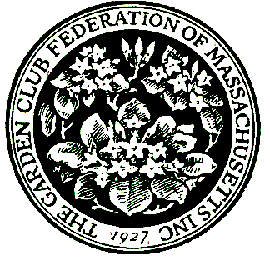
The Garden Club Federation of Massachusetts
400 Fifth Ave., Suite 110, Waltham, MA 02451
Ph: 781-237-0336. Email: GCFMStateAwards@gmail.com

APPLICATION FOR STATE AWARD
Calendar Year 2025
Submissions due December 1, 2025
Exceptions: NOT for Flower Show achievement awards, Special Awards, or Civic Development and Historic Preservation Grants

The application consists of 3 Sections:
Section 1 – Instructions
Section 2 - Submitter and club information
Section 3 – Narrative responses for topics 1 – 6

Section 1 - INSTRUCTIONS

- Please review these instructions before submitting your application.

- If you have questions or need assistance, please email the Awards Chair at GCFMStateAwards@gmail.com

- Refer to the GCFM webpage Awards tab for the State Awards Handbook
for descriptions and additional information.

- Application narrative is limited to three pages – front of pages only.

- Application and supporting material will not be returned.

- Awards year is January 1 – December 31.

- Do not submit an exact duplicate application for more than one award.

- Keep a copy for your records.

- All entries should be sent electronically as a PDF or Word document.

- Email completed application to GCFMStateAwards@gmail.com
to arrive by 11:59 PM on December 1 or earlier.

Section 2 - SUBMITTER AND CLUB INFORMATION
For all applications:
Name of State Garden Club: Garden Club Federation of Massachusetts
Number in State Garden Club: 10,891 members 168 Clubs
State Awards Chair: Lisa Murray
Phone: 978-302-1063
Email: gcfmstateawards@gmail.com

For your submission, complete the following items:

Award #:
Award Name:

Today’s Date:

Your Name :
Phone:
E-mail:

Club President :
Phone:
E-mail:

Club name:
[Enter name exactly as it should appear on any award received]

Town:

Number of members in club:
(Please use the number in your current yearbook)

Section 3 - NARRATIVE: Complete topics 1 to 6, not to exceed 3 pages total. Use the numbering below to complete your application.
1. New project: Yes______ OR continuing from previous work: Yes ______
Beginning date ______________________ Expected completion date ______________________
OR Ongoing ____________

2. Summary of project - include history, objectives, how publicized (if applicable)
3. Involvement of club members (how many), other organizations, collaborations
4. Project expenses and source of funding
5. Continuing involvement, follow-up, maintenance
6. Attach or insert photos
and/or landscape plan (does not need to be professionally drawn)

